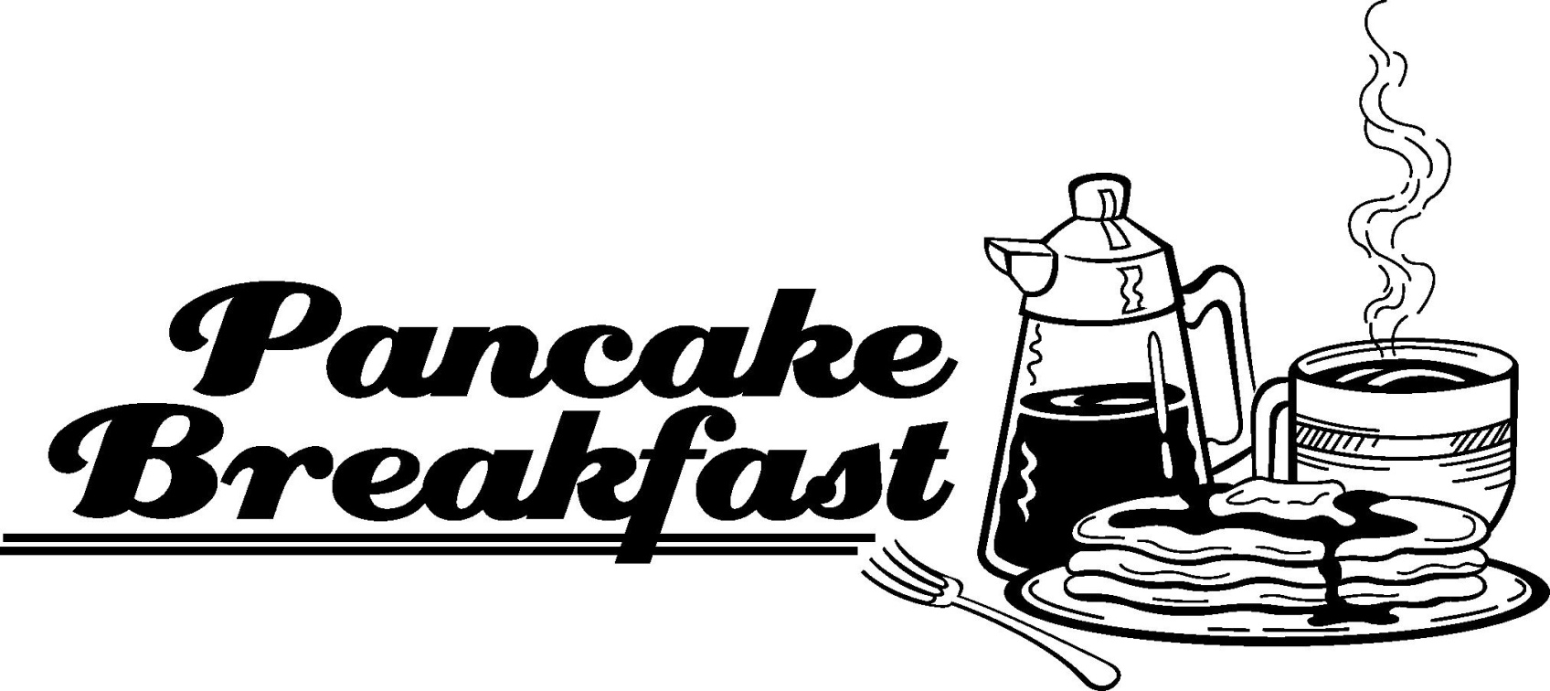

Saturday, May 22, 2021
8:00 a.m. - 11:00 a.m.

Adults $7.00 Children $4.00
Pancakes - Scrambled Eggs - Sausage - Bacon
Orange Juice - Coffee - Tea

Rudolph Elmer American Legion Post 158
527 Philadelphia Avenue
Egg Harbor City, New Jersey

