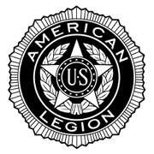
EGG HARBOR CITY * POST 158
and
GALLOWAY TOWNSHIP * POST 430

Join together for 77th Anniversary
“The Four Chaplains” Ceremony

SUNDAY, FEBRUARY 23 at 3:00 p.m.

At the Rudolph Elmer Post 158
527 Philadelphia Avenue
Egg Harbor City
A tribute to
*FOUR MEN,
*THREE FAITHS,
*ONE GOD
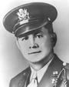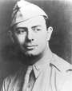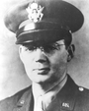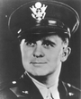

George L. Fox, Alexander D. Goode, Clark V. Poling, John P. Washington

