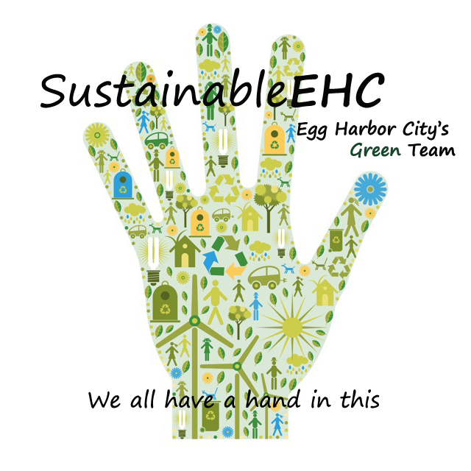
SustainableEHC

Tree Summit
April 30, 2019

Agenda

- Welcome & Introductions

- Presentation 3rd Community Forestry Management Plan – Ron Farr

- Presentation AC Electric Vegetation Management – Ken Mosca of Exelon Corp. and Brittany Peterson of AC Electric Vegetation Management Group

- Webinar – Arbor Day Foundation Community Canopy Program

- Questions & Answers

- Upcoming Events
  - Community Cleanup – May 4 – Start EHC Firehouse, end EHC Lake Pavilion
  - Caring for Orchids – May 7
    - Waldor Orchids presents
    - Mother’s Day Orchids available for purchase
  - Small Space Gardening – May 28
    - Master Gardeners Lecture
    - Pot Party in Peace Pilgrim Park

- Adjournment

www.sustainableehc.org

